UNIT TEST 1 WORKSHEET 1
SUBJECT – SCIENCE
GRADE – V
A. Multiple Choice Questions (MCQs)

1. The framework of bones in our body is called the:
a) Muscular system
b) Skeletal system
c) Digestive system
d) Nervous system

2. Which is the longest bone in the human body?
a) Humerus
b) Femur
c) Tibia
d) Radius

3. The heart is a part of the:
a) Respiratory system
b) Skeletal system
c) Circulatory system
d) Excretory system

4. Which blood vessels carry blood away from the heart?
a) Veins
b) Capillaries
c) Arteries
d) Nerves

5. Red blood cells help in:
a) Fighting germs
b) Clotting blood
c) Carrying oxygen
d) Digesting food

B. True or False

1. The skull protects the brain. _______
2. Bones are soft and flexible. _______
3. The heart pumps blood to all parts of the body. _______
4. Veins carry blood towards the heart. _______
5. Platelets help in clotting of blood. _______

C. Name the Following

1. The system that gives shape and support to the body.

2. The protective bony cage around the heart and lungs.

3. The organ that pumps blood throughout the body.

4. The red-coloured fluid that circulates in our body.

5. The smallest blood vessels connecting arteries and veins.

D. Assertion and Reason Questions
Choose the correct answer:
a) Both Assertion and Reason are true and Reason is the correct explanation of Assertion.
b) Both Assertion and Reason are true but Reason is not the correct explanation of Assertion.
c) Assertion is true but Reason is false.
d) Assertion is false but Reason is true.

1.
Assertion: The skeletal system protects delicate organs.
Reason: The skull protects the brain and the rib cage protects the heart and lungs.
2.
Assertion: The femur is the longest bone in the human body.
Reason: It is present in the upper arm.
3.
Assertion: The heart is called a muscular pump.
Reason: It pumps blood to all parts of the body.
4.
Assertion: Arteries carry blood away from the heart.
Reason: Arteries have thick and elastic walls.
5.
Assertion: White blood cells help fight diseases.
Reason: They protect the body from harmful germs.

E. Fill in the Blanks

1. The point where two bones meet is called a __________.
2. The __________ protects the brain.
3. The heart is located in the __________ cavity.
4. Blood vessels that carry blood towards the heart are called __________.
5. __________ help in clotting of blood when we get injured.

UNIT TEST 1 WORKSHEET 1
A. Multiple Choice Questions (MCQs)
- Question: The framework of bones in our body is called the:
  - Answer: b) Skeletal system
- Question: Which is the longest bone in the human body?
  - Answer: b) Femur
- Question: The heart is a part of the:
  - Answer: c) Circulatory system
- Question: Which blood vessels carry blood away from the heart?
  - Answer: c) Arteries
- Question: Red blood cells help in:
  - Answer: c) Carrying oxygen
B. True or False
- Question: The skull protects the brain.
  - Answer: True
- Question: Bones are soft and flexible.
  - Answer: False (Bones are strong and rigid because they are made of minerals like calcium and phosphorus)
- Question: The heart pumps blood to all parts of the body.
  - Answer: True
- Question: Veins carry blood towards the heart.
  - Answer: True
- Question: Platelets help in clotting of blood.
  - Answer: True
C. Name the Following
- Question: The system that gives shape and support to the body.
  - Answer: Skeletal system
- Question: The protective bony cage around the heart and lungs.
  - Answer: Ribcage
- Question: The organ that pumps blood throughout the body.
  - Answer: Heart
- Question: The red-coloured fluid that circulates in our body.
  - Answer: Blood
- Question: The smallest blood vessels connecting arteries and veins.
  - Answer: Capillaries
D. Assertion and Reason Questions
- Question: Assertion: The skeletal system protects delicate organs. Reason: The skull protects the brain and the rib cage protects the heart and lungs.
  - Answer: a) Both Assertion and Reason are true and Reason is the correct explanation of Assertion.
- Question: Assertion: The femur is the longest bone in the human body. Reason: It is present in the upper arm.
  - Answer: c) Assertion is true but Reason is false. (The femur is present in the upper leg, while the humerus is in the upper arm)
- Question: Assertion: The heart is called a muscular pump. Reason: It pumps blood to all parts of the body.
  - Answer: a) Both Assertion and Reason are true and Reason is the correct explanation of Assertion.
- Question: Assertion: Arteries carry blood away from the heart. Reason: Arteries have thick and elastic walls.
  - Answer: b) Both Assertion and Reason are true but Reason is not the correct explanation of Assertion. (Arteries carry blood away because of the heart's pumping action; their thick walls are a structural adaptation to handle high pressure)
- Question: Assertion: White blood cells help fight diseases. Reason: They protect the body from harmful germs.
  - Answer: a) Both Assertion and Reason are true and Reason is the correct explanation of Assertion.
E. Fill in the Blanks
- Question: The point where two bones meet is called a joint.
- Question: The skull protects the brain.
- Question: The heart is located in the chest cavity.
- Question: Blood vessels that carry blood towards the heart are called veins.
- Question: Blood platelets help in clotting of blood when we get injured.

UNIT TEST 1 WORKSHEET 2
SUBJECT – SCIENCE
GRADE – V
F. Answer the Following in Short
1. What is the skeletal system?
2. Name any four major bones of the human body.
3. What is the function of the rib cage?
4. What is the main function of the heart?
5. Name the three main types of blood cells.

G. Answer the Following in Detail
1. Explain any five functions of the skeletal system.
2. What are joints? Describe any three types of joints with examples.
3. Describe the structure and function of the heart.
4. Explain the composition of blood and the functions of its different components.
5. Differentiate between arteries, veins, and capillaries.
Feature | Arteries | Veins | Capillaries
Direction of blood flow
Thickness of walls
Function

H. Picture Study
Picture Study – 1: Human Skeletal System
Study the picture carefully and answer the following questions:
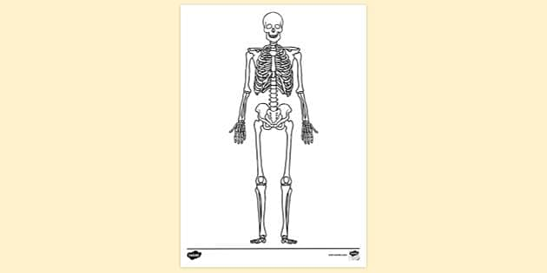
1. Name the bone that protects the brain.
2. Which bone forms the rib cage?
3. What is the longest bone in the human body?
4. Name the backbone shown in the picture.
5. State two functions of the skeletal system.

Picture Study – 2: Human Circulatory System
Study the picture carefully and answer the following questions:
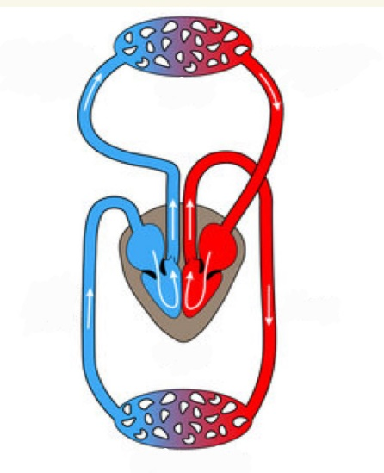
1. Which organ pumps blood throughout the body?
2. Name the blood vessels that carry blood away from the heart.
3. Name the blood vessels that carry blood towards the heart.
4. What are the smallest blood vessels called?
5. What is the main function of the circulatory system?

UNIT TEST 1 WORKSHEET 2
F. Answer the Following in Short
- Question: What is the skeletal system?
  - Answer: The skeletal system is the rigid framework of all the bones present in our body that supports the body and gives it a definite shape.
- Question: Name any four major bones of the human body.
  - Answer: The skull, backbone (vertebral column), ribcage, and femur (thigh bone).
- Question: What is the function of the rib cage?
  - Answer: The ribcage protects delicate internal organs such as the heart and the lungs.
- Question: What is the main function of the heart?
  - Answer: The main function is to pump blood containing oxygen and nutrients to all cells in the body and receive blood containing carbon dioxide to pump it to the lungs for purification.
- Question: Name the three main types of blood cells.
  - Answer: Red blood cells (RBCs), White blood cells (WBCs), and blood platelets.
G. Answer the Following in Detail
- Question: Explain any five functions of the skeletal system.
  - Answer: (1) Shape and support: It provides the framework for the body. (2) Protection: It shields delicate organs like the brain and heart. (3) Movement: It allows various body parts to move. (4) Production: Bone marrow inside bones produces red blood cells. (5) Storage: Bones store essential minerals like calcium.
- Question: What are joints? Describe any three types of joints with examples.
  - Answer: A joint is a place in the skeleton where two or more bones connect. Three types are: (1) Ball-and-socket joint: Allows movement in all directions (e.g., shoulder and hip). (2) Hinge joint: Allows back-and-forth movement (e.g., knees and elbows). (3) Pivot joint: Allows sideways movement (e.g., neck).
- Question: Describe the structure and function of the heart.
  - Answer: The heart is a muscular organ about the size of a fist, consisting of four chambers: two upper atria (receive blood) and two lower ventricles (pump blood out). Its function is to continuously pump oxygenated blood to the body and transport deoxygenated blood to the lungs for purification.
- Question: Explain the composition of blood and the functions of its different components.
  - Answer: Blood consists of a fluid part called plasma and three types of cells: (1) RBCs: Transport oxygen and carbon dioxide. (2) WBCs: Protect the body from infections and germs. (3) Platelets: Help the blood to clot at injury sites.
- Question: Differentiate between arteries, veins, and capillaries.
  - Answer:
Feature | Arteries | Veins | Capillaries
Direction of flow | Away from the heart | Towards the heart | Connects arteries to veins
Thickness of walls | Thickest walls | Thinner than arteries | Thinnest of all
Function | Carry oxygenated blood | Carry impure blood | Facilitate exchange of gases
H. Picture Study
Picture Study – 1: Human Skeletal System
- Question: Name the bone that protects the brain.
  - Answer: Skull.
- Question: Which bone forms the rib cage?
  - Answer: Ribs and Sternum (breastbone).
- Question: What is the longest bone in the human body?
  - Answer: Femur.
- Question: Name the backbone shown in the picture.
  - Answer: Vertebral column (or spine).
- Question: State two functions of the skeletal system.
  - Answer: (1) It gives shape and support to the body. (2) It protects delicate internal organs.
Picture Study – 2: Human Circulatory System
- Question: Which organ pumps blood throughout the body?
  - Answer: Heart.
- Question: Name the blood vessels that carry blood away from the heart.
  - Answer: Arteries.
- Question: Name the blood vessels that carry blood towards the heart.
  - Answer: Veins.
- Question: What are the smallest blood vessels called?
  - Answer: Capillaries.
- Question: What is the main function of the circulatory system?
  - Answer: It transports nutrients, water, and oxygen inside our body and removes waste gases like carbon dioxide.

